JOB DESCRIPTION

Budget/Establishment/Unit: Germany Enabling Office

Branch/Department: Customs & Borders (C&B) Liaison Office

Location: Paderborn - Sennelager

Post Title: Customs & Borders Administrator

Grade: C4

Responsible to: Head of Customs & Borders Liaison Office

Vetting Requirement: Cat 3

For regular employment with Germany Central

1. GENERAL

The Germany Enabling Office is the UK Defence in-country Authority responsible and accountable for the conduct of all UK Defence activity in Germany in accordance with the NATO Status of Forces Agreement (NATO SOFA) and its Supplementary Agreement (SA to NATO SOFA).

The post incumbent performs work of a clerical nature as an Office Administrator in an office-based role under the general supervision of the Head of Customs & Borders (C&B) or determined deputy.

2. MAIN DUTIES

- Daily administration of e-mail correspondence within the C&B Group Mailbox and via the standard postal system. Categorisation of correspondence for direct response to the customer / organisation or redirection to the relevant internal departmental lead for further action.
- Processing of all incoming customs-related paperwork and preparation of official documentation as required for signature by the Head of C&B or determined deputy.
- Validation, cross-referencing and updating of information against associated internal information management resources.
- Collation of key documentation for investigations into the misuse of the Official Procurement Agencies (OPA) tax-free purchasing system and the import / export of personal goods.
- Daily liaison with other UK Government departments for the processing of customs-related applications and the input of relevant data onto external encrypted information management systems.
- Provide advice and guidance to UK Defence organisation support staff on customs-related process and procedure.
- Provide online and face-to-face training delivery of C&B process / procedure and refresher training to current and new personnel with the GEO and UK Defence organisation support staff.
3. OTHER DUTIES

  - On request of the employer, the postholder must attend courses which are suitable to improve professional skills.
  - The postholder is required to deputise for other personnel during their absence, as directed by the employer.
  - Carry out any other reasonable duties which are within the scope of the employer’s right of directive.

4. DRIVING OF DUTY VEHICLES

The post incumbent is not required to drive duty vehicles.

5. OVERTIME/WORK ON SUNDAYS AND/OR PUBLIC HOLIDAYS

Must work overtime at request of the employer.

6. SHIFT WORK/ROTATING SHIFT WORK

Regular shift work or rotating shift work is not a feature of the employment.

7. ON-CALL DUTIES

On-call duties are not a feature of the employment.

8. MEDICAL

A medical examination is not a prerequisite for this employment. However, employees must undergo medical examinations in accordance with Health and Safety at Work provisions or other relevant provisions as necessary.

9. REQUIRED PROFESSIONAL QUALIFICATIONS/EXPERIENCE

- Essential

- Very good knowledge of the English language (Common European Framework of References for Languages – CEFR level C1), both verbal and written. Ability to correspond and communicate effectively in the English language by e-mail and telephone.
- Practical experience working with productivity software such as Word, Excel, PowerPoint, Outlook and SharePoint.
- Ability to work well within a small team and with the minimum of supervision.
- Good organisational, interpersonal and communication skills. The ability to deal politely and efficiently with customer enquiries either by e-mail or telephone.
- Ability to work calmly and accurately when under time and volume pressure.

- Desirable

- Basic understanding of the NATO SOFA and Supplementary Agreement.
- Clerical or administrative background.
- IT user qualification.

10. HEALTH AND SAFETY AT WORK

Post holders are obliged to take care of their own safety and health at their place of work within their ability and in accordance with the instructions and orders of the employer. Furthermore, they are also obliged to take care of the safety and health of persons who are affected by their actions or omissions at work. Within the frame of these rules, they are especially required to use machinery, equipment, tools, working substances, working materials, transport aids and any other working aids as well as protective equipment and the issued personal protective equipment in accordance with the requirements. They must report any direct and considerable danger to health and safety as well as failures of the safety systems to the employer or the relevant supervisor without any undue delay.

11. TRAVEL EXPENSES

Post incumbents are not entitled to payments for kilometres driven to and from their place of work to residence. If they are required to perform their duties outside the employment agency, they will be entitled to travel claims in accordance with the current regulations.

12. ORGANISATION CHART

The post incumbent’s position in the organisation is shown below; this may change due to reorganisation or a redeployment and addition to staff.

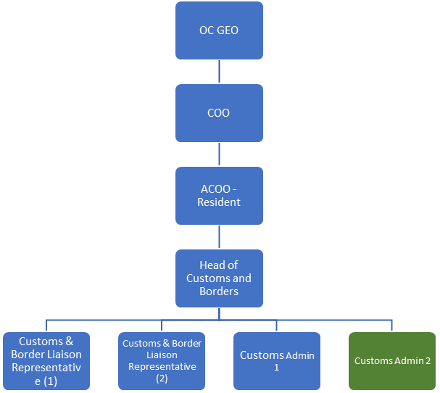

Date Signature Employee

